JAVA - Hibernate:

Jar files – Java class files or packages are wrapped inside a rar file.

Hibernate is a framework, the boilerplate code which is already written we access the methods.

Hibernate mainly revolves around ORM tool.

Hibernate implements the specifications of JPA.

Hibernate Architecture:   
===================

1. POJO class represent the values
2. Mapping configuration files.
3. Hibernate configuration class.

POJO (Plain old java object) – It consists of all variables as private and to access them we write setter and getter methods.

Mapping.xml – Information of variable of pojo class representing a column of table.

* Pojo class name represents the table name and variable name represents the column names

Example:

Student.xml

<hibernate-mapping>

<class name=”com.ex.student” table=student>

<id name=”primary key” column=”sid”/>

<property name=”sname” column=”sname”/>

</class>

</hibernate-mapping>

Hibernate config file:

* Config.xml: database connection and information of all the tables. Also contains hibernate properties. Automatic generation of queries and mapping file

<hibernate-configuration>

<session-factory>

<property name=”connection.driver_class”>com.mysql.jdbc.Driver</property>

<property name=”connection.url”>jdbc:myslq://localhost:3306/employee</property>

<property name=”connection.user”>root</property>

<property name=”connection.password”>root</property>

<property name-“show_sql>true/false</property>

<property name=”dialet”><org.hibernate.dialect.MySQLDialect</property>

<property name=”hbm2ddl.auto”>create/update </property>

<mapping resource=”student.xml”/>

</session-factory>

</hibernate-configuration>

Flow of hibernate:

Config file needs to be create.

Session Factory – contains connection and mapping resource inform

Session – session object – session is open internally db connection object created

Transaction- commit and rollback

Close objects

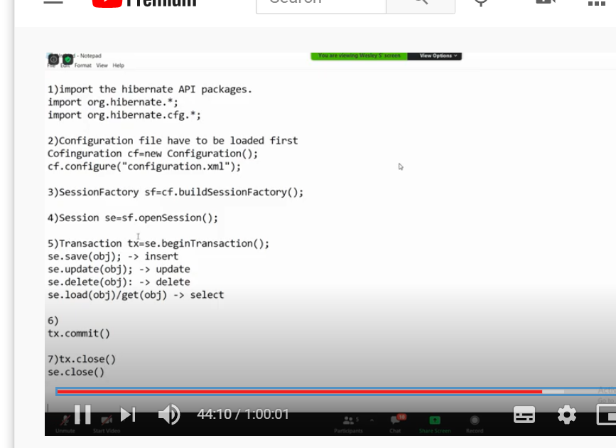

Flow of hibernate:

Read the configuration file,

Session Factory contains all the information related to the connection and mapping resource. Here whatever config contains the entire information object is created using session factory

Hibernate: Inheritance Mapping

1. Table per class hierarchy  
   +++++++++++++++++++++

Payment.java(superclass)

Creditcard.java and cheque.java(derived class)

Client.java

Payment.xml(only one mapping file)

Config.xml (paymentype is discriminator column and value is directly given in xml)

1. Table per sub class hierarchy
2. Table per concrete class hierarchy